Renju lesson on November 30, 2000

Hello all! Welcome to Online Renju Class.
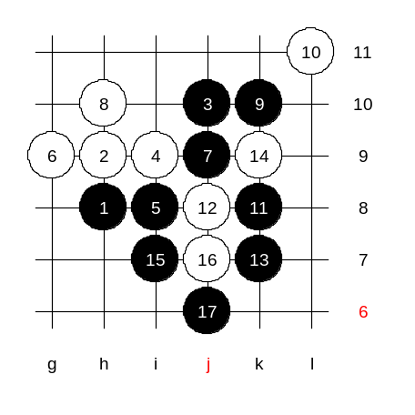
We will continue learning the same 5th move we learned last week. We use another 6th move today. Black looks very strong here, but in fact in is not true. The outcome is quite equal. First, lets see what happens if white plays aggressively to h10, trying to give pressure on 3x3 point. What should black do now? Can black win here? Alright, we try k10 as you suggested. And now? It seems that both 11-j7 and 11-k8 lead to similar positions. Alright, lets try k8. How to win now? Which 15th move? Alright, I will give you the idea. There are hundreds of situations in renju games where we face similar questions. Usually those situations are all solved in standard way. Please remember it, we will show it now. After j6, black has VCF threat. Do you all see it? Black material is sufficient for victory in case of any white move.

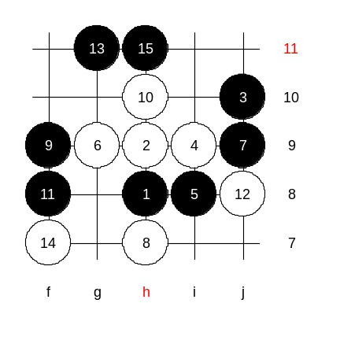
Now, let’s play a serious 8th move. There are two possible 8th moves. I guess some of you know them. Well, those who said h7 and j8 are right. Move 8-g8 is too active and does not block much, 8-k10 is too passive and does not connect with other white stones. Move h7 is pretty good. It blocks a black line, and also connects with f9 point (and keeps the 3x3 still open). Many people make a wrong choice here. They play actively as black and lose soon. In fact, black cannot attack now because of absence of VCT and growing white counter-attack base. Simple is best - black's best move is f9. You ask if it is possible to play 10-h10. Well, black does not have VCT after that, but it does not mean h10 is good. We can try it to make sure about it. Lets try an active 15-h11. Who can defend here? Actually, we do not need to get into details here. The most important is that we see that 10-h10 was quite poor move and should not be used.

Lets try some other 10th moves. Move 10-j8 is one of the possibilities. Has anyone if you ever seen that move before? Who has read the article in our website that tells about the basic tactics, they must know that in most cases the best defense is blocking the 3x3 point. Hasegawa used the same move against me in the World Championship.
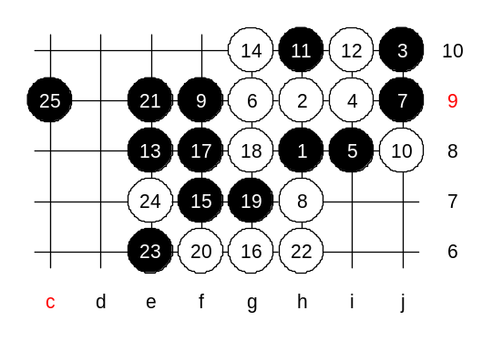
I was black in that game. Lets see how it ended. Although the traditional old style is 13-f7, I do not like it because it gives very passive and equal position. I used more aggressive move e8 as i had also made some analysis about it before the game. I expected him to play 14-f7. Two other games in the WC were played using 14-f7. I was prepared for that. But he didn’t. He surprised me with another 14th move g10. What should black do now? White has 3x3 at g8. Yes, I played f7. He played g6, blocking my diagonal line. I didn’t want to rush during that game, and spent almost 1 hour to make sure about VCT win. Move 25-c9 the final of the attack. Black win is close. No matter how white defends, black win is really simple.

Move 10-g7 - another idea.
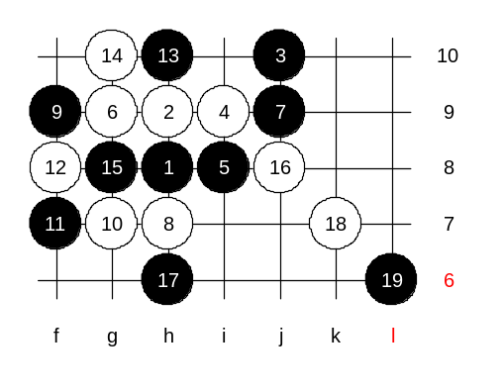
White keeps the 3x3 open and plays actively. Black tactics about those 3x3 situations - black tries to keep this material open as long as possible, so that later it could effectively help black developments in any directions. Therefore black plays 11-f7 now. White continues the idea of his previous move. White plays 12-f8 and keeps the 3x3 open. Now, white has 3 open lines on the board. It is time for black to start balancing. As I said, breaking the 3x3 is the last choice for black. If there is any other move possible, black will use that other move. Move h10 is good enough. It blocks one white line, and controls another one. An the third white line alone is useless. Now, white cannot attack because of absence of VCT. White continues balancing too - g10. Moves until 17th are traditional theory here. I know those 17 being used long time before I began to play renju. It is very balanced position. Some games here are won by black, some by white, and some end with draw. Black stones stand better though. Therefore white has to use the tempo to fill the board and not let black get the initiative too soon. Moves 18-k10 and 18-k7 are both very popular continuations. Lets play k7. Black uses L6 in order to surround white stones. There are no sure conclusions about the outcome of the variant. People try so many different continuations here. Everyone of you may try to find their own ideas and style here.

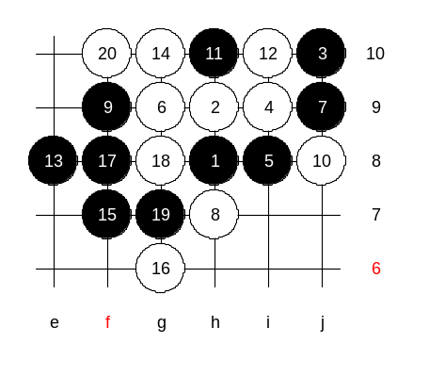
Lets set up the homework position.
This is the medium level homework.
Please find the black win.

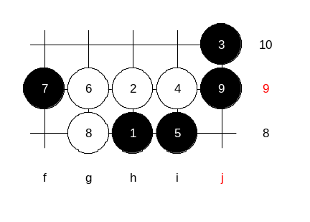

This is the advanced level homework. Try to find white win here. I am not 100% sure if white has win or not, but this is your homework to find out.

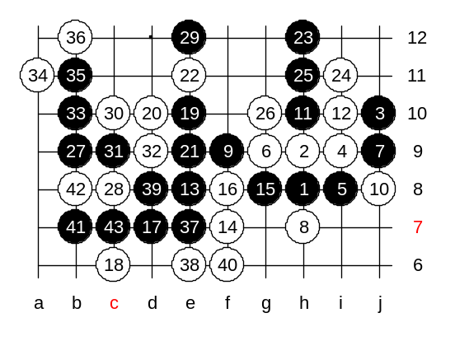
The lesson is over now. Who want to leave, may go. Those who want to stay may play the game teacher vs students. I will play some gambling move, and give you chance to win. And you have to prove your team spirit of you can win or not. Remember, you have winning position. Now it is all up to you.
Wow, you finally win! Good teamwork! I am proud of you! :)

